**Name: Siobhan Gavin**

**Student Number: 20012203**

**Course: Higher Diploma in Science in Business Systems Analysis**

**Year: 5**

**Module: Web Development**

**Final Report on MMA Waterford Website**

Contents

**Website Details:** 3

**Overview of website:** 3

**Usernames and passwords for restricted areas:** 4

**Evaluation of Website:** 5

**A.** **Problems encountered & solution to problem** 5

**B.** **What you learned/what you might do differently next time.** 5

# **Website Details:**

**URL:** <http://sgavin.x10host.com/Index.php>

# **Overview of website:**

MMA Waterford is a mixed martial arts club. On the home page users can see a small note about the club and the menu that gives the user access to a more detailed description of some of the classes thought, the contact page where a user can send a query to the club, the classes page where the user can see all of the classes available, the times they are held at and the coach that teaches the class, the user can then use the register page to register their details and become a member, after this they may log in on the login page and then they will gain access to the members only area where they can book classes and edit/delete bookings that they have made.

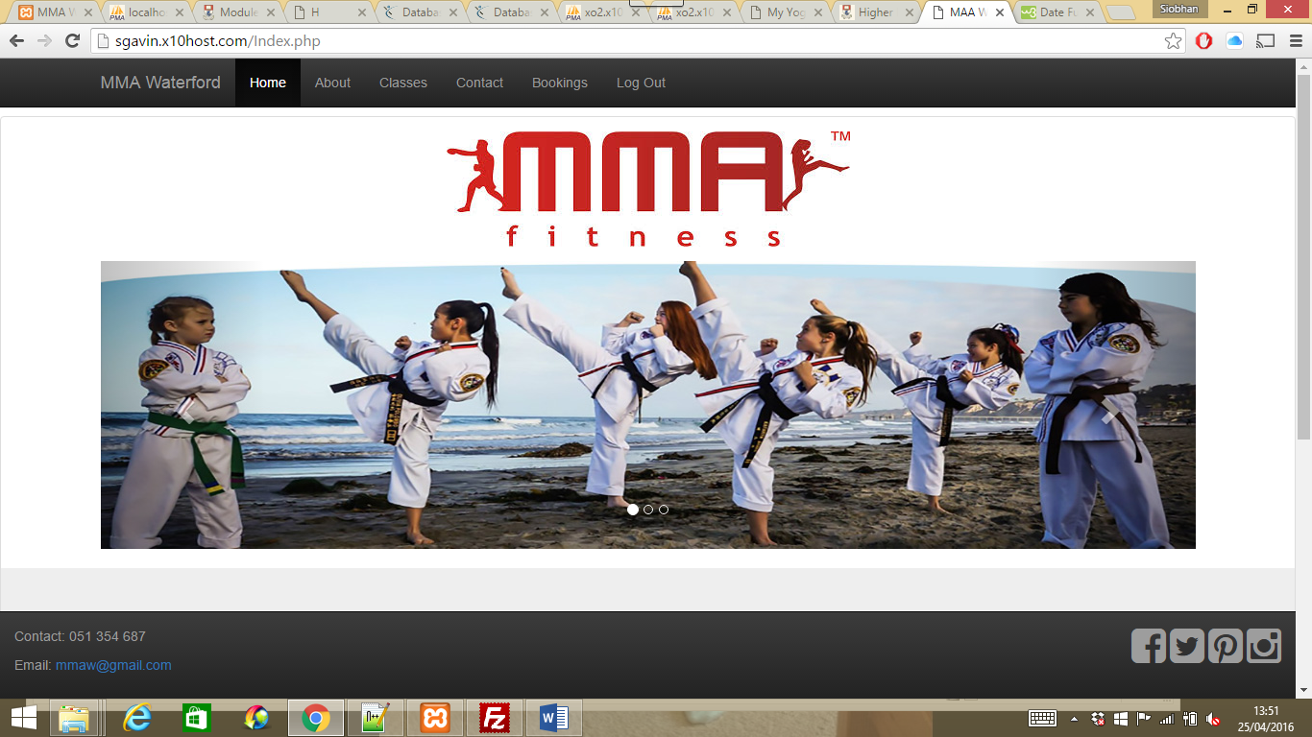

# **Usernames and passwords for restricted areas:**

|  |  |
| --- | --- |
| **Username:** | **Password:** |
| sgavin | liverpool |
| sarad | Sdunphy |
| mmurphy | hello |
| sgibson | samg |

# **Evaluation of Website:**

## **Problems encountered & solution to problem**

When creating this website I encountered a few problems, mainly down to typos! The use of uppercase and lower case letters and simply just misspelling words that were important in links to other pages or within SQL statements. To fix this issue I double checked all spellings. I don’t feel that while creating the website there were any other problems which I encountered.

The main problem encountered after this was hosting the website. When uploading the files they were not appearing on the website and a ‘not found’ error repeatedly showed itself, also when trying to establish the database I repeatedly could not gain access to phpmyadmin within x10hosting. My solution to this problem was to create a new account with x10hosting and go from there. From here everything seemed to go according to plan the web pages appeared in an index when sgavin.x10host.com was accessed however within the website the menus would not work. I discovered that file names were more case sensitive than before. Some files I had uploaded had uppercase letters in them but not within the files where I had created links using the file names, this issue was fixed by editing the links within the files and re-uploading. From here the website worked as it should, registering users and allowing them to log in and displaying their bookings to edit and delete.

## **What you learned/what you might do differently next time.**

From completing this assignment on creating a website I have learned some of the aspects of JavaScript, bootstrap, php. I have revised database modelling also. I have learned how to link up your website with your database and how to use SQL statements to interact with the database and display the required information based on the user’s inputs or their log in details. I also learned how to host my website online.

The things I would do differently next time would be to take more time and be more careful with spellings and syntax, I feel at times I rushed some of it and ended up with issues and had to re-do a lot which resulted in taking more time.